ResistantAI TotalAgility Connector

Pocket Guide

July 2025  
Version 6.0

Contents (“UPDATE TABLE” after placing content)

Table of Contents

What is the ResistantAI TotalAgility Connector? 4

Technical Assets included in the Package 4

Why Tungsten Automation Marketplace? 5

How does the ResistantAI TotalAgiligy Connector work? 5

Architecture of the connector 6

TotalAgility import 7

Getting started 7

Connector Methods. 7

Network Traffic and Firewall Requirements 9

Resistant Documents – Whitelisting 9

Frequently Asked Questions? 10

Storage 10

Detection 11

Who do I need to contact to get the Resistant AI private keys & the user credentials? 11

Version History

|  |  |  |
| --- | --- | --- |
| 06/22/2024 | Version 1 | Initial version. |
| 08/28/2024 | Version 2 | New demo site & streamlined forms |
| 01/17/2025 | Version 3 | Includes new fields and additional functionality |
| 05/09/2025 | Version 4 | Added load testing process, re-try logic & token caching |
| 12/06/2025 | Version 5 | Updated Submission logic to consider Adaptive Decision Requirement from TA. Added a new method to retrieve Adaptive Decision Result |
| 07/17/2025 | Version 6 | Updated Network and Firewall requirements |

# What is the ResistantAI TotalAgility Connector?

Forgery Detection system protects business processes and automated workflows from forgery-based frauds. The solution inspects financial documents, bank statements, and other documents submitted to our customers for signs of manipulation and raises an alert when a modification, file corruption, inconsistency with past behavior, or other anomaly is found by the AI-based system.

The TotalAgility connector built with ResistantAI provides straight-through processing of documents and images via the ResistantAI REST APIs.

# Technical Assets included in the Package

The Tungsten Labs ResistantAI Connector consists of a .Net Framework v4.8 DLL (tungstenlabs.integration.resistantai.dll) which will aid in obtaining and presenting the information extracted by ResistantAI through the Connector. We also have included a TotalAgility Package:

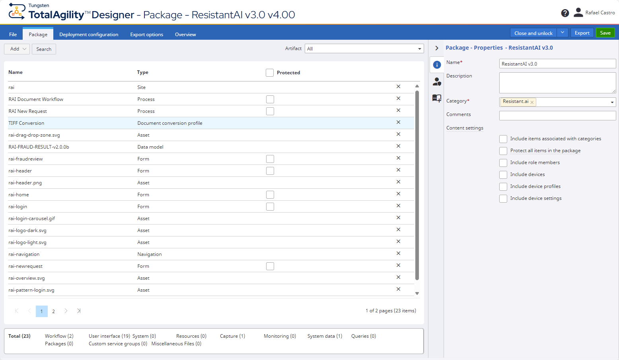

* Business Processes: The package will include the following business processes:
  + RAI New Request: A process which takes care of all new incoming requests by creating a new single image analysis request
  + RAI Document Workflow: A process which handles single-document analysis request against the Resistant.ai API.
  + **RAI-DocRequest-LoadTesting:** A process to call the dll in a load testing scenario.
  + **RAI-DocumentLoadTesting:** A process which will start a load testing scenario for you; within the process you can select multiple documents and send it a number of times to the ResistantAI API to load test your solution.
  + **Resistant Restarter:** This job, in conjunction with the “Resistant Restart Scheduler” job schedule, will find any suspended job for the ResistantAI Load testing process and will automatically restart it until it is completed successfully.
* DLL: .NET Framework v4.8 DLL (tungstenlabs.integration.attestiv.dll) which performs all the necessary functions to communicate with Resistant.ai’s API and return the analysis information
* UX Forms: Used to run the demo that includes uploading a document and displaying the document analysis results.
  + Site:A dedicated site so you can demonstrate the Resistan.ai Connector; the site can be reached by <Your TotalAgility URL>/forms/rai. It includes a specialized workqueue which displays the current analysis results as well as images that are rejected for not meeting the minimum requirements.
  + New request form:This is the form you would use in order to create a new document fraud analysis request using the Resistant.ai connector.
  + **Fraud Review form:** This form is used to display the analysis results from ResistantAI.

# Why Tungsten Automation Marketplace?

The Tungsten Automation Marketplace is a digital showcase of assets connecting customers with pre-built, integrated components and solutions to extend their digital workforce. The ResistantAI TotalAgility Connector will be easily available on Marketplace, built on top of Kofax’s Intelligent Automation platform. It accelerates customer automation journeys and reduces the need for custom development work. The Kofax Marketplace also allows partners to expose their value-added solution to new prospects and customers.How do I download the ResistantAI Connector from Marketplace?

The solution is available at <https://marketplace.tungstenautomation.com/> and downloadable from our Github repositoty ([**TungstenAutomationLabs/ResistantAIConnector: Helper functions to integrate with Resistant AI to facilitate fraud checks.**](https://github.com/TungstenAutomationLabs/ResistantAIConnector)). It comes with a detailed readme file which describes how to set up the solution in TotalAgility.

# How does the ResistantAI TotalAgiligy Connector work?

The connector handles all REST calls into the ResistantAI API, including:

#### Upload document file to ResistantAI.

The connector will ingest and send the raw file to the ResistantAI platform; the connector will take care of all authentication and REST API handling.

#### Retrieve fraud detection results from ResistantAI.

The connector will get the submission ID once the file is uploaded, and will get the fraud results from the ResistantAI API (currently v2), and will bring back all data for the document.

#### Output the extraction results to the calling process.

When the extraction results are retrieved, the JSON can be turned into a data model variable or used raw for further processing.

# Architecture of the connector

TotalAgility connects with the Resistant.AI services through number of API’s within the TotalAgility workflow to automate the customer experience without any hassle of setting up or configuring document parameters, settings or preferences.

The below diagram shows:

* The documents received via multi-channel are ingested by TotalAgility
* TotalAgility calls the Resistant AI API’s to send the JSON payload over a secured channel
* The result is received in a form of JSON
* A TotalAgility Form displays the document along with its indicators

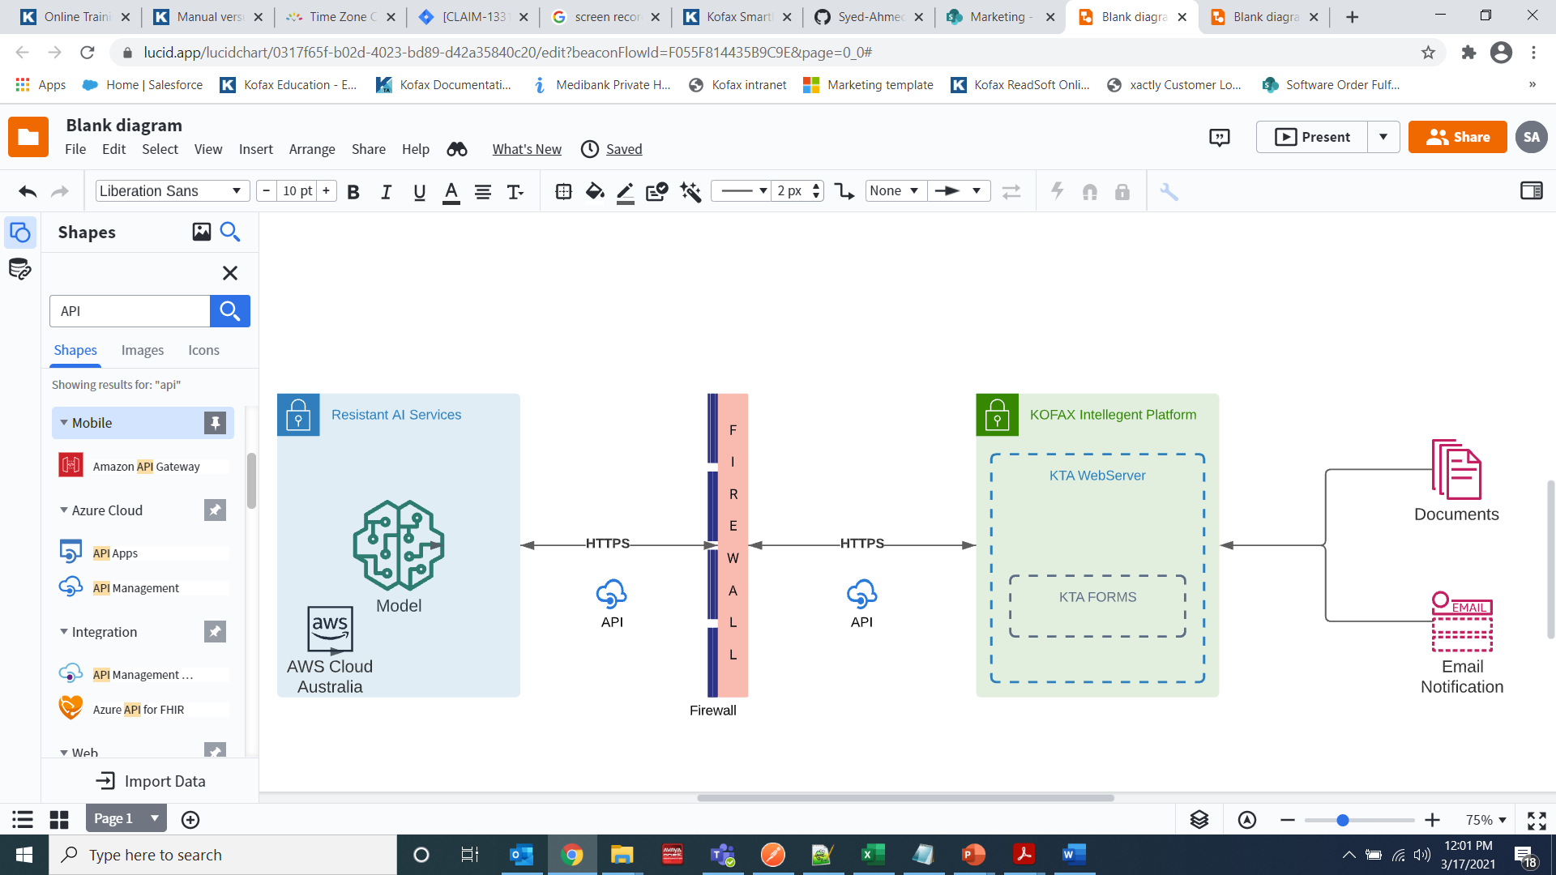

# TotalAgility import

The documents can be ingested by TotalAgility through different means (email, shared folder watch, scan client). The ResistantAI TotalAgility Connector is designed to handle one document at a time, so if you have multiple files or a folder setup, it is best to call the Connector within a document iteration loop.

# Getting started

Before you get started with the ResistantAI connector, please make sure you have a working account with them (<https://resistant.ai/>); for any questions, please contact your sales representative. Once your account is created, you can get your client id, secret & all you will need in order to send files & extraction requests.

After you have the ResistantAI authentication, please follow the steps below:

1. Follow the steps to install the ResistantAI Connector Package to a TotalAgility instance.
2. Import the tungstenlabs.integration.resistantai.dll into your TotalAgility instance.
3. To call the connector from a workflow activity, create a .Net activity and configure the method as desired.
4. The function you would need to call is to upload the file to ResistantAI service & fetch results.
5. Once you have the JSON results, you can either assign them to a data model or use it for further processing.

# Connector Methods.

Tungsten Automation Labs’ ResistantAI Connector exposes one methods to assist you in getting the information you need from ResistantAI:

* UploadFileAndFetchResults: this method would get the document.instance ID, use the TotalAgility SDK to get it, then upload it to ResistantAI. ResistantAI will then return a submissionID which will be used to fetch the results back:
  1. AuthenticationURL: URL provided by ResistantAI for safe authentication.
  2. SubmissionURL: URL provided by ResistantAI to submit all requests.
  3. ClientID: Client ID provided by ResistantAI.
  + ClientSecret: Client Secret string provided by ResistantAI.
  + DocID: TotalAgility document ID (normally is Document.InstanceID).
  + TASDKURL: path to the TotalAgility SDK to be used.
  + TASession: The TotalAgility session ID to be used.
* UploadFileAndFetchResultsWithRetries: similar to the previous method, this one also adds retry logic as well as a mechanism to identify any suspended jobs caused by any exception so that the jobs can be restarted:
  1. AuthenticationURL: URL provided by ResistantAI for safe authentication.
  2. SubmissionURL: URL provided by ResistantAI to submit all requests.
  3. ClientID: Client ID provided by ResistantAI.
  4. ClientSecret: Client Secret string provided by ResistantAI.
  5. DocID: TotalAgility document ID (normally is Document.InstanceID).
  6. TASDKURL: path to the TotalAgility SDK to be used.
  7. TASession: The TotalAgility session ID to be used.
  8. NumberOfRetries: An integer with the maximum number of retries to do per API call.
  9. SuspendReason: An out string parameter which will return the suspend reason; this is used in the Restarter process.
* GetAdaptiveResult

This method retrieves the Adaptive Decision Result and Reason for the given submission. For this to work effectively, a server variable 'RAI-ENABLE-DECISION' should be added in TotalAgility. If this variable has value of true, dll internally passes true for enable decision parameter for Submission. GetAdaptiveResult is able to retrieve the result successfully only when subission has sent the parameter as true. Otherwise GetAdaptiveResult sends a response 'Adaptive Decision feature was not enabled for this submission.'

* 1. SubmissionURL: URL provided by ResistantAI to submit all requests.
  2. SubmissionId: SubmissionID returned by ResistantAI after successful submission.
  3. TASDKURL: path to the TotalAgility SDK to be used.
  4. TASession: The TotalAgility session ID to be used.

# Network Traffic and Firewall Requirements

## Resistant Documents – Whitelisting

When integrating the Resistant AI Connector with an on-premise TotalAgility environment, it's essential to ensure that the required outbound network traffic is permitted from the TotalAgility server (or source system). This allows seamless communication between TotalAgility and the Resistant AI platform for document analysis, result retrieval, and authentication.

The connector communicates with Resistant AI services over TCP port 443 using the HTTPS protocol. The firewall or network configuration must allow access from the TotalAgility server (source) to the respective Resistant AI endpoints (destinations) as outlined below.

Depending on whether you are operating in a Production or Testing environment, the required destinations differ slightly. Ensure all relevant domains are reachable from within your environment.

Production environment domains

|  |  |
| --- | --- |
| {tenant-org}.{region.}[documents.resistant.ai](http://documents.resistant.ai) | (R.Documents static UI assets) |
| [api.tenants.resistant.ai](http://api.tenants.resistant.ai) | (R.Documents API) |
| api.{region.}[documents.resistant.ai](http://documents.resistant.ai) | (Resistant Documents API) |
| [eu.id.resistant.ai](http://eu.id.resistant.ai) | (Okta OAuth2 authentication API/assets) |
| *.okta.com | (Okta OAuth2 authentication API/assets) |
| *.oktacdn.com | (Okta OAuth2 authentication API/assets) |
| s3.{aws-region}.amazonaws.com | (R.Documents file upload/download) |
| *.s3.amazonaws.com | (R.Documents file upload/download) |
| *.[productfruits.com](http://productfruits.com) | (R.Documents UI product demo tour) |

Note 1: Depending on the geographical region in which the customer's tenant exists, the shortened region identifier {region} is either omitted in case of “eu-1” or is inserted as a subdomain (e.g. “us-1.”, “ca-1.” or “ap-2.”). Its AWS variant {aws-region} must be present in all cases and values correspond with AWS region identifiers (e.g. “eu-west-1”).

Note 2: S3 wildcard domain can be replaced with a more specific one if necessary ([bp-pdf-forjerry-upload-forjerry-prod.s3.amazonaws.com](http://bp-pdf-forjerry-upload-forjerry-prod.s3.amazonaws.com)), but always prefer wildcard in case we need to migrate to a different bucket.

Testing environment domains

|  |  |
| --- | --- |
| {tenant-org}.{region.}[documents.testing.resistant.ai](http://documents.testing.resistant.ai) | (R.Documents static UI assets) |
| [api.tenants.testing.resistant.ai](http://api.tenants.testing.resistant.ai) | (R.Documents API) |
| api.{region.}[documents.testing.resistant.ai](http://documents.testing.resistant.ai) | (Resistant Documents API) |
| [eu.id.resistant.ai](http://eu.id.resistant.ai) | (Okta OAuth2 authentication API/assets) |
| *.okta.com | (Okta OAuth2 authentication API/assets) |
| *.oktacdn.com | (Okta OAuth2 authentication API/assets) |
| s3.{aws-region}.amazonaws.com | (R.Documents file upload/download) |
| *.s3.amazonaws.com | (R.Documents file upload/download) |
| *.[productfruits.com](http://productfruits.com) | (R.Documents UI product demo tour) |

Note 1: Depending on the geographical region in which the customer's tenant exists, the shortened region identifier {region} is either omitted in case of “eu-1” or is inserted as a subdomain (e.g. “us-1.”, “ca-1.” or “ap-2.”). Its AWS variant {aws-region} must be present in all cases and values correspond with AWS region identifiers (e.g. “eu-west-1”).

Note 2: S3 wildcard domain can be replaced with a more specific one if necessary

([bp-pdf-forjerry-upload-forjerry-testing.s3.amazonaws.com](http://bp-pdf-forjerry-upload-forjerry-testing.s3.amazonaws.com)), but always prefer wildcard in case we need to migrate to a different bucket.

# Frequently Asked Questions?

Below is the list of possible questions gathered to answer the basic questions about storage and detection

## Storage

Is data stored in the cloud? And how long is it stored?

Yes. To ensure maximum system performance and support flexibility, the Resistant AI service is offered primarily via the cloud. It is completely up to the customer to choose the document retention period. By default, our recommendation is at least 90 days

How do you secure the transfer of the data? and what happens after the document is uploaded to the server?

Data transfer is handled via secure TLS connection. Each user is authenticated using an API key in the https header. Upon submitting a file to the server, a unique ephemeral environment is deployed to process the file. As soon as the analysis is complete, the environment is destroyed, and the result of the analysis is returned to the caller.

How many documents can the system process simultaneously?

The solution is designed to process documents in parallel and independently from one another. The maximum allowed time in the test to process the 1,000 documents simultaneously is 60 second.

## Detection

What type of files do you support?

The ResitantAI solution supports the following type of files: PDF, JPEG, PNG, TIFF and HEIC.

How long does it take to process a document?

When it comes to analyzing digital PDF documents, the p95 speed is around 15 seconds. Processing images is a bit more demanding, taking anywhere up to 35s.

What languages do you support?

Forgery detection works for any writing system.

Are there any limits when it comes to the size of the document?

AWS S3 limits file sizes of up to 5GB. The only technical limitation for the document processing is the associated 15-minute timeout. Any processing that takes longer than this will not succeed.

## Who do I need to contact to get the Resistant AI private keys & the user credentials?

The Private Authorization key & account can be requested on the email provided below along with the reference of Tungsten Marketplace.

[sales@resistant.ai](mailto:sales@resistant.ai)

Once the package is downloaded and imported in TotalAgility, the private key can be replaced in the server variables section as described below:

|  |  |
| --- | --- |
| **Key** | **Value** |
| Authorization Key | Private authorization key for API calls to happen. |
| File Upload Directory | Computer directory through which KTA will ingest the files, check import settings in KTA for watched folder name |
| Do not change below, unless consulted or advised | |
| Document Viewer URL | Internal to Resistant – URL on which the document viewer is built |
| Get File Upload URL | Internal to Resistant – S3 File upload URL |
| Get Analysis URL | Internal to Resistant – Analysis URL for getting the results |